DBMS 🡪 63/100  
OS 🡪 70.5/100  
TOC 🡪 61.5/100  
CAO 🡪 76.33/100  
UID 🡪 71.33/100  
EEE 🡪 78.83/100  
Hindi 🡪 74.58/100  
STATS 🡪 71/100  
Soft skills 🡪 79.9/100

DBMS

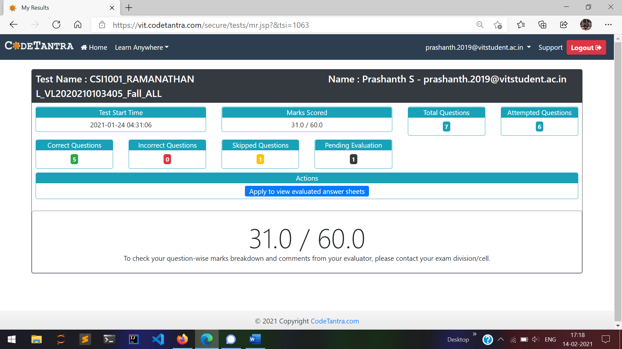

UID

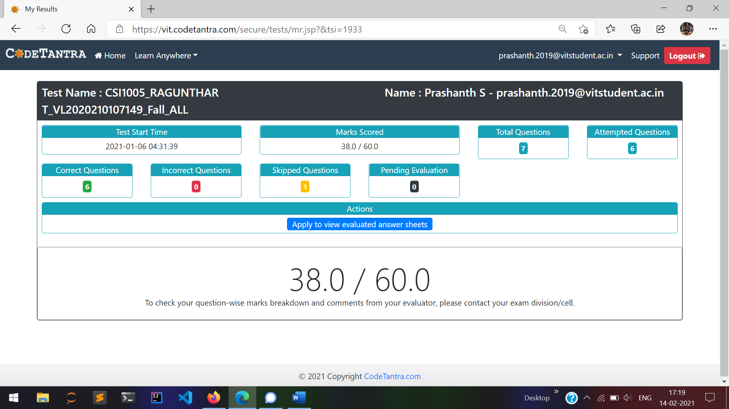

OS

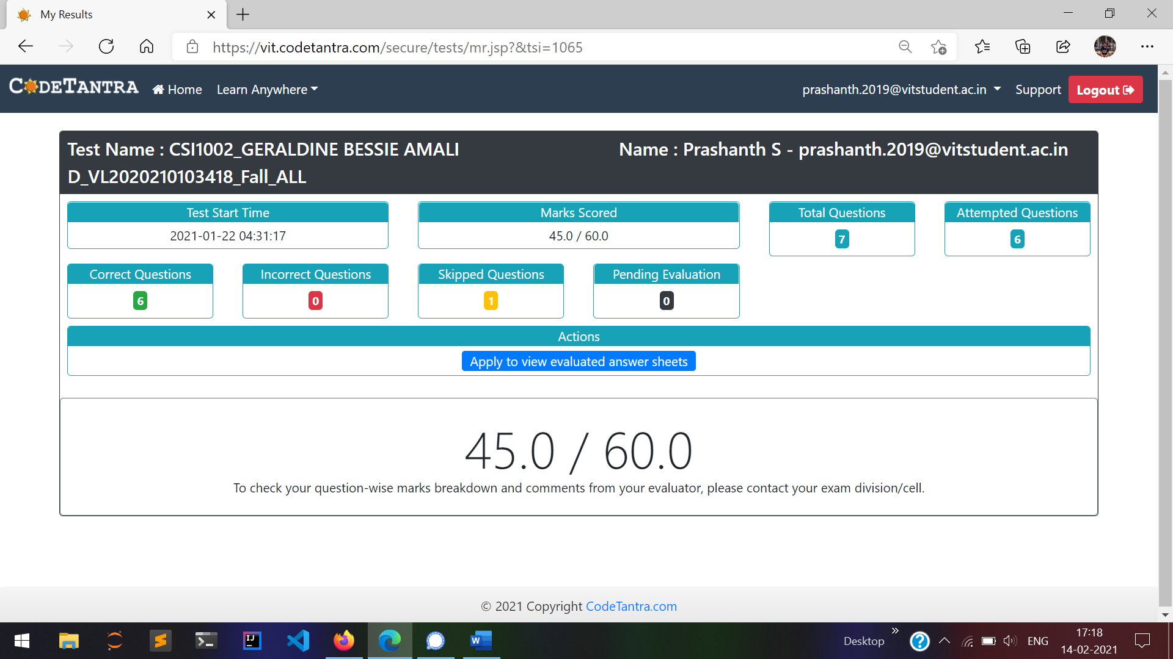

CAO

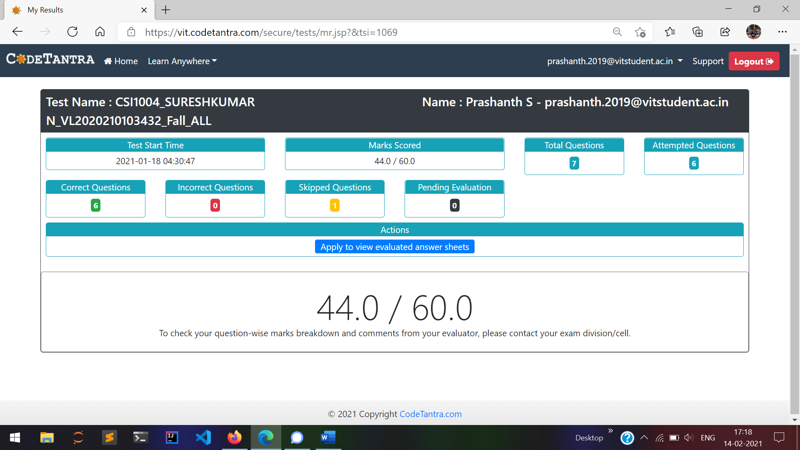

Hindi

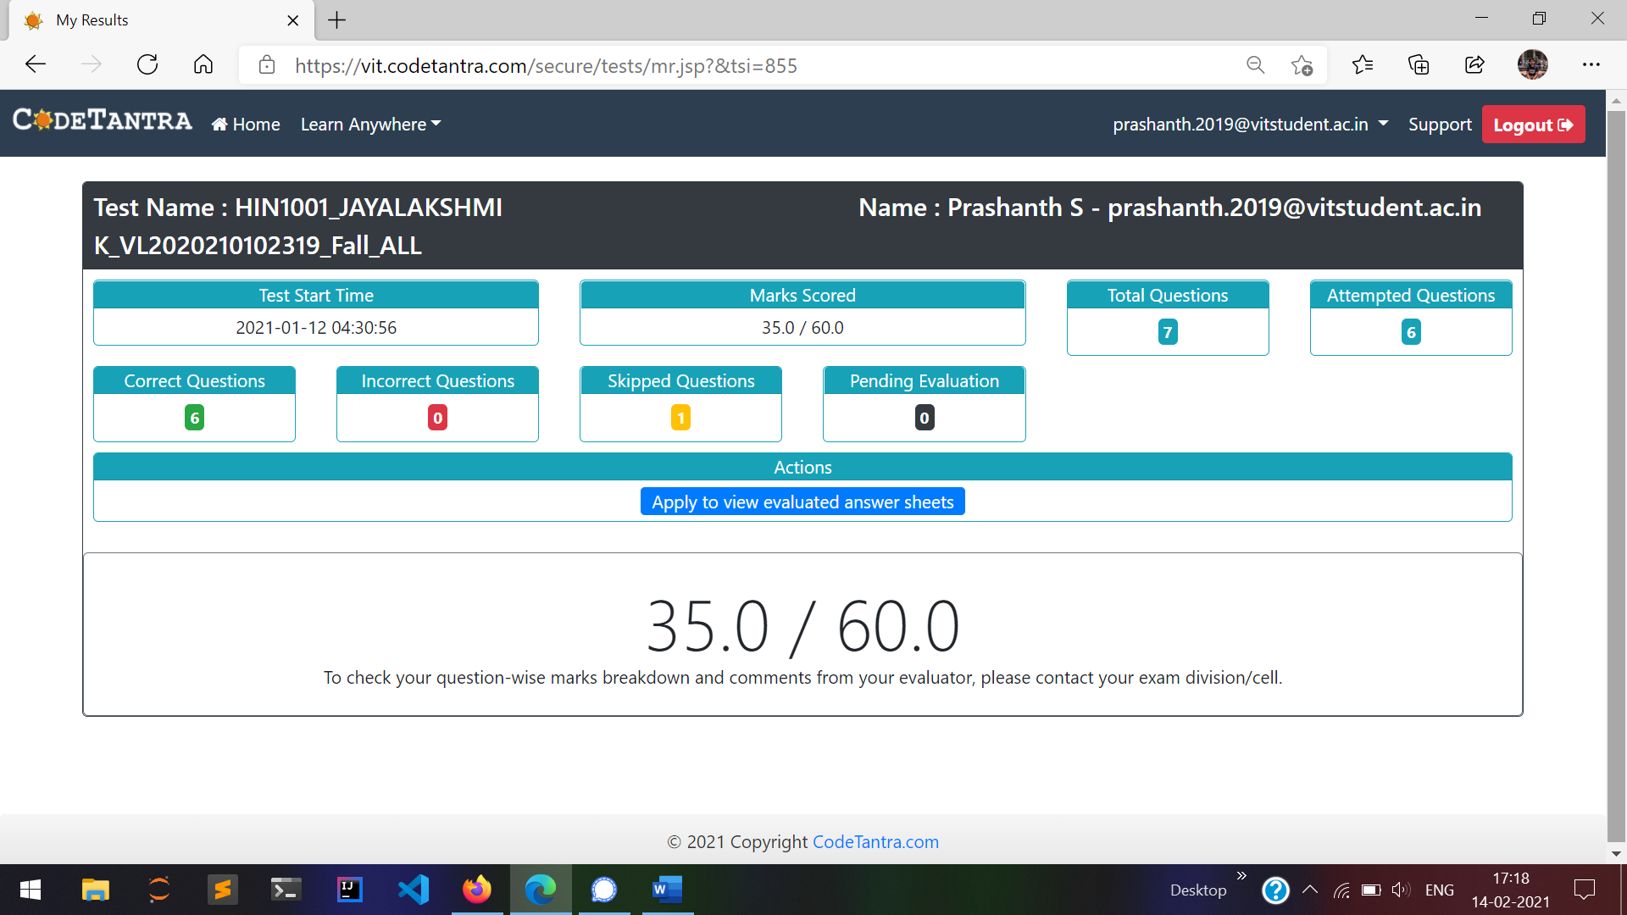

Statistics

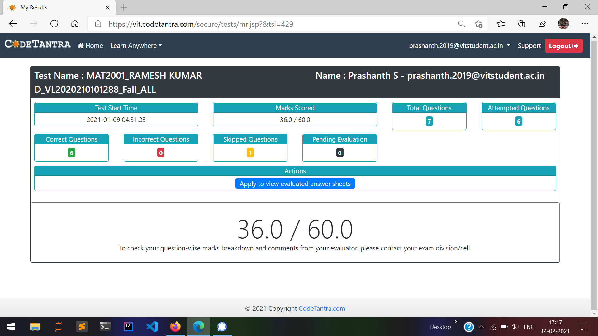

EEE

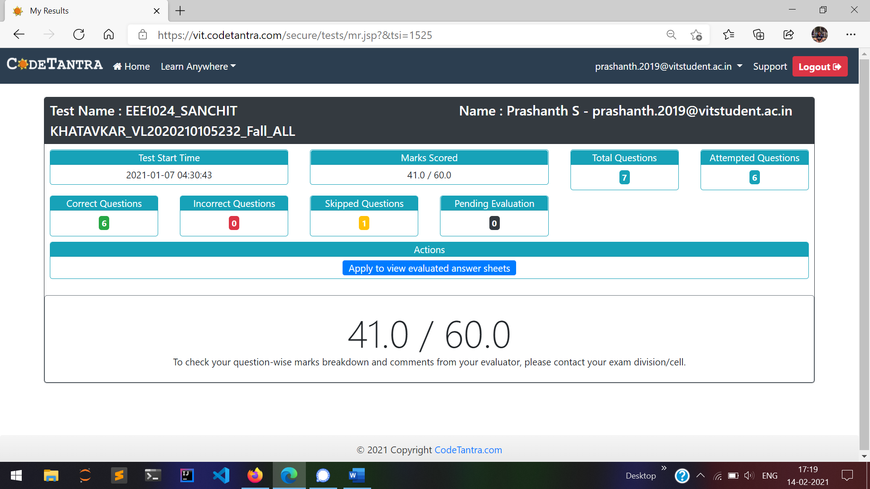

TOC

